Iterative Query

🔁 What is an Iterative Query in DNS?
# Source: AI Source: Provided by: [Data Path: Persons Table -> ID Column: 1, Name_En Column: Motasem Essam] -> From: [ChatGPT] on [1/18/2026]
An iterative query is a type of DNS request where the DNS client (usually a resolver) asks a DNS server for an answer — and if the server doesn't know it, it doesn't fetch the answer itself, but instead replies with a referral to another DNS server.
🧠 In an iterative query, each DNS server tells you where to look next, rather than doing the work for you.

🔍 Example of an Iterative Query
# Source: AI Source: Provided by: [Data Path: Persons Table -> ID Column: 1, Name_En Column: Motasem Essam] -> From: [ChatGPT] on [1/18/2026]
Let’s say a recursive resolver wants to resolve www.example.com. Here's how it works step-by-step using iterative queries:
- Resolver asks the Root Server:
🔹 “What is the IP for www.example.com?”
🔸 Root says: “I don’t know, but ask the .com TLD server.”
- Resolver asks the .com TLD Server:
🔹 “What is the IP for www.example.com?”
🔸 TLD says: “Ask the authoritative server for example.com.”
- Resolver asks the Authoritative Server:
🔹 “What is the IP for www.example.com?”
🔸 Authoritative server replies: “The IP is 93.184.216.34.”
- Resolver returns the final answer to your device.

📌 Characteristics of Iterative Queries
# Source: AI Source: Provided by: [Data Path: Persons Table -> ID Column: 1, Name_En Column: Motasem Essam] -> From: [ChatGPT] on [1/18/2026]
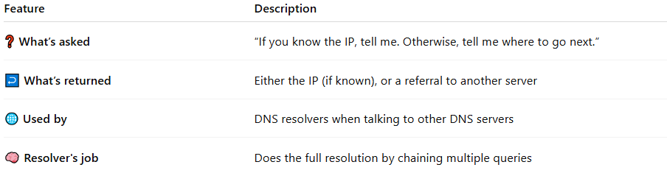

Feature | Description
❓ What’s asked | “If you know the IP, tell me. Otherwise, tell me where to go next.”
↩️ What’s returned | Either the IP (if known), or a referral to another server
🌐 Used by | DNS resolvers when talking to other DNS servers
🧠 Resolver's job | Does the full resolution by chaining multiple queries

🔁 Recursive vs Iterative Query
# Source: AI Source: Provided by: [Data Path: Persons Table -> ID Column: 1, Name_En Column: Motasem Essam] -> From: [ChatGPT] on [1/18/2026]
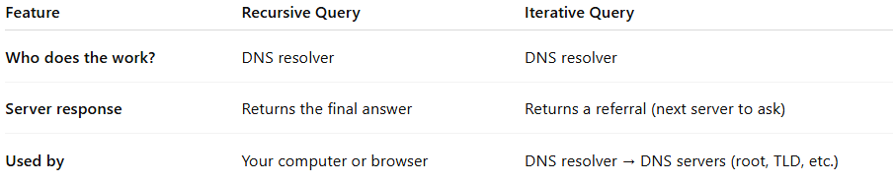

Feature | Recursive Query | Iterative Query
Who does the work? | DNS resolver | DNS resolver
Server response | Returns the final answer | Returns a referral (next server to ask)
Used by | Your computer or browser | DNS resolver → DNS servers (root, TLD, etc.)

✅ Summary
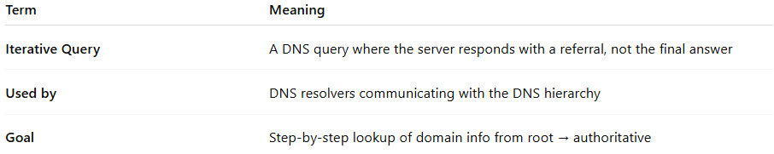

Term | Meaning
Iterative Query | A DNS query where the server responds with a referral, not the final answer
Used by | DNS resolvers communicating with the DNS hierarchy
Goal | Step-by-step lookup of domain info from root → authoritative

